**LUOR summary**

**Bellfountain**

> anova(bf.lm)

Analysis of Variance Table

Response: leaves

Df Sum Sq Mean Sq F value Pr(>F)

Grass 1 19519.5 19519.5 13.1563 0.003976 **

Forb 1 14749.3 14749.3 9.9412 0.009194 **

Moss 1 2813.8 2813.8 1.8966 0.195842

Litter 1 5719.6 5719.6 3.8550 0.075373 .

Bare 1 2834.9 2834.9 1.9107 0.194303

Disturbed 1 4860.8 4860.8 3.2762 0.097665 .

Vole 1 3.998e-02 3.998e-02 2.695e-05 0.995951

AvLD 1 1167.6 1167.6 0.7869 0.394007

Residuals 11 16320.3 1483.7

---

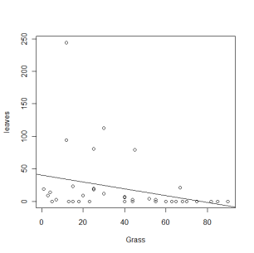lm(formula = leaves ~ Grass, subset = (Site == "Bellfountain"))

Coefficients:

Estimate Std. Error t value Pr(>|t|)

(Intercept) 93.4459 28.3162 3.300 0.00398 **

Grass -1.2987 0.4823 -2.692 0.01489 *

Multiple R-squared: 0.2871,

> confint(bf.grass.lm)

2.5 % 97.5 %

(Intercept) 33.955740 152.9360463

Grass -2.312088 -0.2853310

---

Call:

lm(formula = leaves ~ Forb, subset = (Site == "Bellfountain"))

Coefficients:

Estimate Std. Error t value Pr(>|t|)

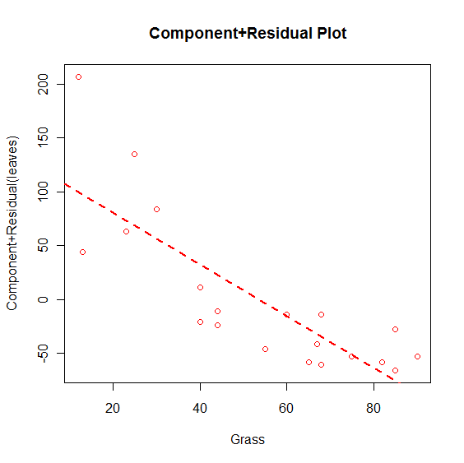(Intercept) 20.9454 22.1062 0.947 0.356

Forb 0.1191 0.6986 0.171 0.866

Multiple R-squared: 0.001613,

-------

Call:

lm(formula = leaves ~ Forb + Grass, subset = (Site == "Bellfountain"))

Residuals:

Min 1Q Median 3Q Max

-53.262 -31.520 -4.915 22.392 107.342

Coefficients:

Estimate Std. Error t value Pr(>|t|)

(Intercept) 200.1490 46.0612 4.345 0.00044 ***

Forb -1.9285 0.7072 -2.727 0.01434 *

Grass -2.3982 0.5779 -4.150 0.00067 ***

Multiple R-squared: 0.5041,

> confint(bf.both.lm)

2.5 % 97.5 %

(Intercept) 102.968310 297.3295985

Forb -3.420558 -0.4364719

Grass -3.617353 -1.1789789

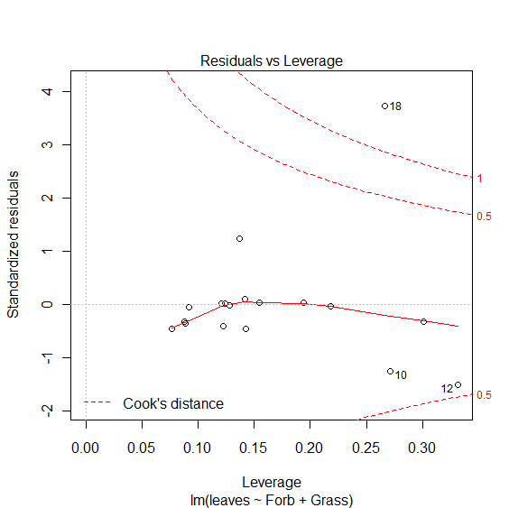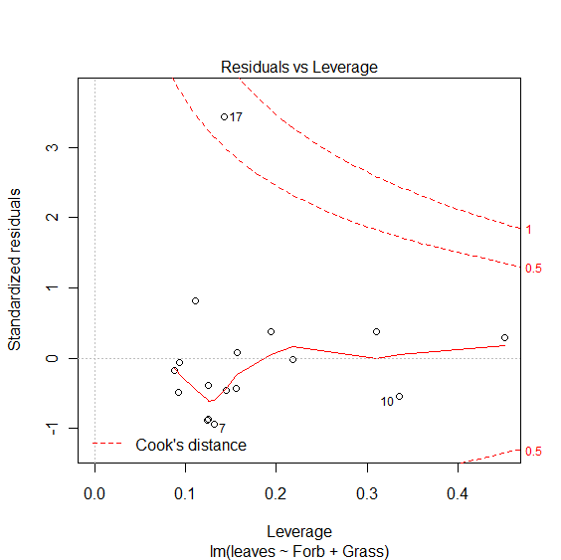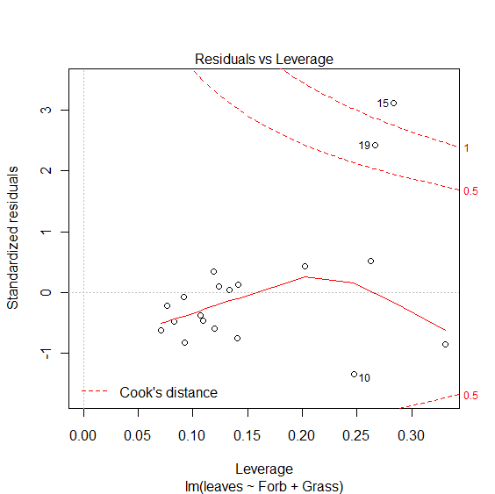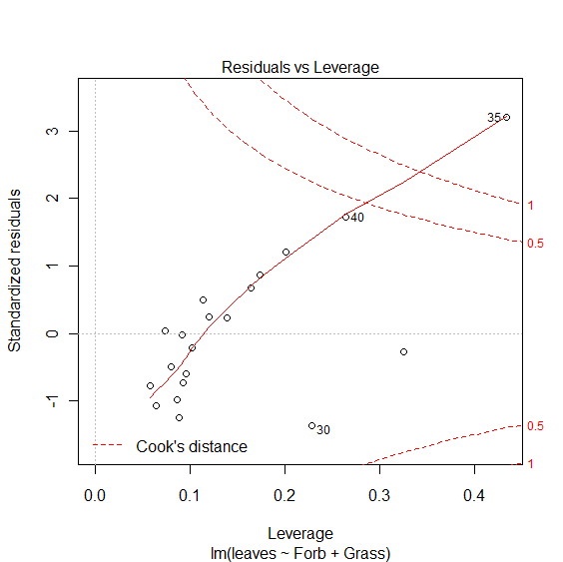

Omit 35,15,18

Call:

lm(formula = leaves ~ Forb + Grass)

Residuals:

Min 1Q Median 3Q Max

-4.5028 -2.3080 -0.8727 1.1261 16.4201

Coefficients:

Estimate Std. Error t value Pr(>|t|)

(Intercept) 15.74775 8.28856 1.900 0.0782 .

Forb -0.19097 0.11496 -1.661 0.1189

Grass -0.15243 0.09981 -1.527 0.1490

**too many influential points**

**Log transformation of leaves**

Call:

lm(formula = log.leaves ~ Forb + Grass)

Residuals:

Min 1Q Median 3Q Max

-8.3100 -3.0164 -0.7136 3.3779 8.8326

Coefficients:

Estimate Std. Error t value Pr(>|t|)

(Intercept) 11.84738 5.12996 2.309 0.03374 *

Forb -0.16333 0.07876 -2.074 0.05361 .

Grass -0.22676 0.06436 -3.523 0.00261 **

Multiple R-squared: 0.4277

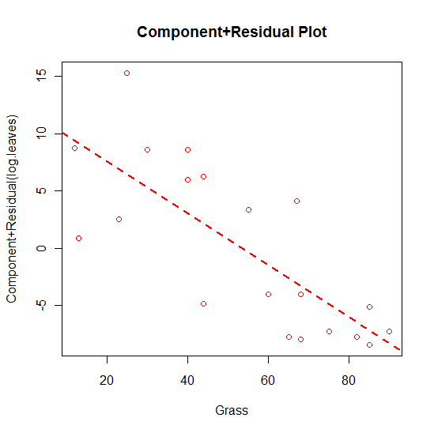

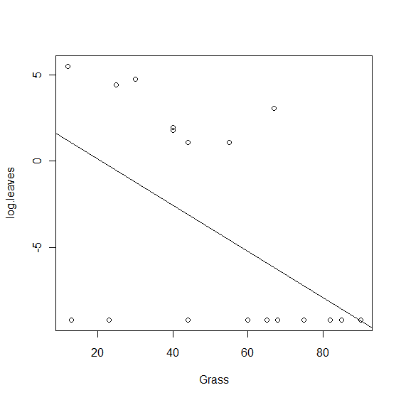

**Ft. Hoskins**

> fh.lm<- lm(leaves~Grass+Forb+Moss+Litter+Bare+Disturbed+Vole+AvLD,

+ subset=(Site=="Ft. Hoskins"))

> anova(fh.lm)

Analysis of Variance Table

Response: leaves

Df Sum Sq Mean Sq F value Pr(>F)

Grass 1 165.5 165.5 0.2098 0.6567

Forb 1 450.0 450.0 0.5704 0.4675

Moss 1 514.0 514.0 0.6514 0.4384

Litter 1 48.0 48.0 0.0609 0.8101

Bare 1 1890.3 1890.3 2.3958 0.1527

Disturbed 1 59.8 59.8 0.0757 0.7888

Vole 1 1308.7 1308.7 1.6587 0.2268

AvLD 1 138.9 138.9 0.1760 0.6837

Residuals 10 7890.0 789.0

Coefficients:

Estimate Std. Error t value Pr(>|t|)

(Intercept) 19.7790 9.6960 2.040 0.0563 .

Grass -0.1680 0.2835 -0.593 0.5608

Coefficients:

Estimate Std. Error t value Pr(>|t|)

(Intercept) 3.3189 12.9282 0.257 0.800

Forb 0.2796 0.2725 1.026 0.318

Coefficients:

Estimate Std. Error t value Pr(>|t|)

(Intercept) 6.30039 18.82803 0.335 0.742

Forb 0.25372 0.30288 0.838 0.414

Grass -0.06912 0.30933 -0.223 0.826

**nothing of interest**